**Module 2:** **Safety and security on Cyber Space LESSON PLAN** 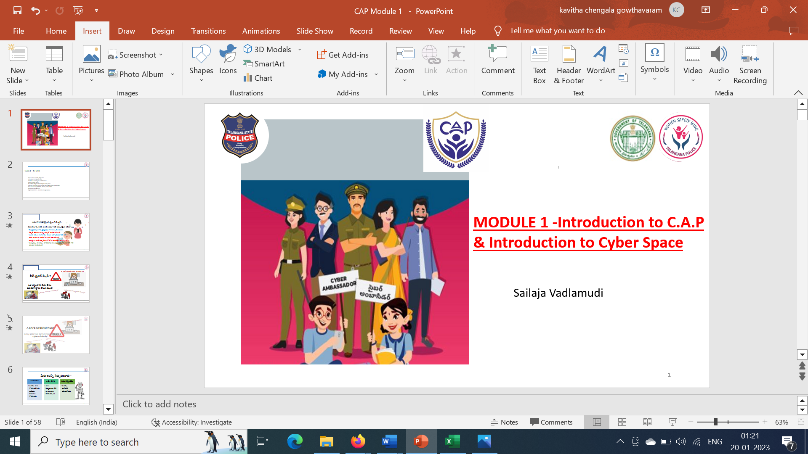

**Learning Outcome**

|  |
| --- |
| On successful completion of the module, learners: |
| **Knowledge :** |
| ·       Awareness on the browser security implementations for safe browsing |
| ·       Understanding the password and email security measures |
| ·       Appraisal on social media privacy and safe usage like FB, Insta, Twitter, Linked in, Youtube |
| ·       Identifying and apprising the need for updating the software on various apps , laptop cameras and webcams |
| ·       Recognising the importance of Security while using android devices |
| ·       Describe the importance of installing the antivirus |
| **Skills :** |
| ·       Collaborate effectively with different stake holders like mentor teachers, trainers, she team officers , officer in charge , volunteer mentors |
| ·       Apply effective oral, written, and visual communication skills to create awareness on cyber safety |
| **Application of knowledge and skills :** |
| ·       Apply the skills and knowledge gained to securely browse the digital space |
| ·       Demonstrate the skill to install the antivirus and updating the software |
| Appraise the safe browsing techniques while using the public wifi and social media |

**LESSON PLAN ;**

|  |  |  |
| --- | --- | --- |
| **LESSON NAME /SUBTOPIC** | **MODE /TIME REQUIRED /PPT/ OTHER TEACHING TOOLS** | **EQUIPMENT REQUIRED /ACTIVITY /TIME** |
| Pre assessment | Pre assessment -5 questions (MCQ) to understand the knowledge of the students | **Zoom poll survey -5 min ..** |
| Creating awareness on the WOMEN SAFETY WING and district SHE TEAM OFFICERS group pic with names of each zone | Group pic of WOMEN SAFETY WING officers and District SHE TEAM OFFICERS pic | **PPT with 2 group pics with names -3 min** |
| Ice breaker - video on Centre of excellence | Function of centre of excellence and the interesting activities that happen – constable – Rajalingam Goud | **Video – 2.3 min** |
| Ice breaker – Video -on cyber safety as career | Motivating Video by cyber security expert Mr Sunny | **Video – 2.3 min** |
| Recap of previous session | **SLIDES 1 TO 4** | **2 min** |
| Basic Security Policies (desktop, Usb, documents) | Trainer will open the live screen to demonstrate securities **SLIDES 6 TO 13** | **5 min** |
| Browser Security Implementations  - Safe Browsing - Cookies - Clear Cookies & Histroty data  - Google Search ,Toll free numbers | Trainer will open the live page to demonstrate the security implementations **SLIDES 14 TO 18** | **5 min** |
| Password Security Measures |
| Email Security |
| Social Media Privacy ( FB, Insta, Twitter, Linked in, Youtube ), - Privacy & Security Settings - Multifactor Authentication - Securing Personal Data | Trainer will open the live page to demonstrate the security functions **SLIDES 19 TO 36** | **12 min** |
| Instant Messenger Safety (Whats App, Snap Chat,Telegram) |
| Public WiFi |
| Windows Security and Updation of Softwares and apps Laptop Cameras, Web Cams | Trainer will open the live page to demonstrate the security functions **SLIDES 37 TO 61** | **10 min** |
| Android Security - Play Store  - Installation of apps - Permissions | Trainer will open the live page to demonstrate the security functions **SLIDES 62 TO 67** | **3 min** |
| AntiVirus -List and Installation | Trainer will showcase the list from the real web pages **SLIDES 68 TO 73** | **3 Min** |
| Post Assessment explanation | The timeline for completing the post assessment shall be given like an hour from the end of the session. Cyber Ambassador have to log in to the website and answer the questions. There are 10 questions pertaining to the syllabus. | **2 min** |
| Activity 1 and 2 Narration | Time line to complete this activity is 3 weeks from the time of completing the second module .Narration given below . | **3 min** |

**PREASSESMENT QUIZ QUESTIONS :**

**Mode : Zoom poll which can give the percentage of yes or no is used to assess the knowledge and experience of students in cyber space**   
**Questions :**

**POSTASSESMENT QUESTIONS**

**ACTIVITY IN CYBER AMBASSADOR PLATFORM (C.A.P)**

**CybHER # Cybersafe For Her**

**ACTIVITY TITLE 1 for Module 2 : BE A REAL-LIFE HERO**

**PARTICIPANTS:** Mentor teachers, Cyber Ambassadors, Students

**WHEN IS THIS DONE:** After the second module session the activity shall be finished within 2 weeks’ time

**MODUS OPERANDI: Think of 1 way you can help your classmates stay safe in cyberspace. Make a video** telling us what is that 1 thing you will do to help your classmates stay safe on the internet. Explain that in your school assembly. At the end of your short video, add these lines -"I choose to be cyber smart. I choose to be a Cyber Ambassador."

**LANGUAGES**: English or any local language or bilingual as well

**ACTIVITY VIDEOS AND PICS** : To be shared with us through jot forms as and when provided

**OUTCOME OF THIS ACTIVITY:** To create a community impact starting with the co students of the school on the knowledge acquired.

**ACTIVITY TITLE 2 FOR Module 2 :**

**Make a poster with your picture in centre ( your name and Cyber ambassador ) has to be mentioned on nine elements of Digital Citizenship and explain it to all the students ( Be as creative as possible )**  